Task1

1. CREATE 3 DIFFERENT USERS IN YOUR SYSTEM (USE BOTH GUI, AND TERMINAL FUNCTIONALITY)

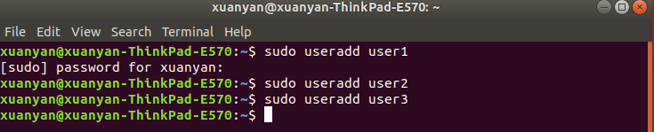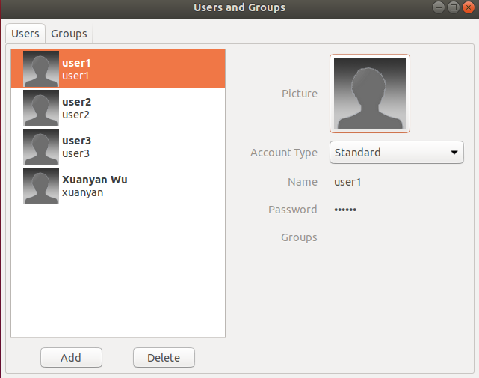

2. INCLUDE THEY IN GROUP WITH THE NAME “RIM-181229”



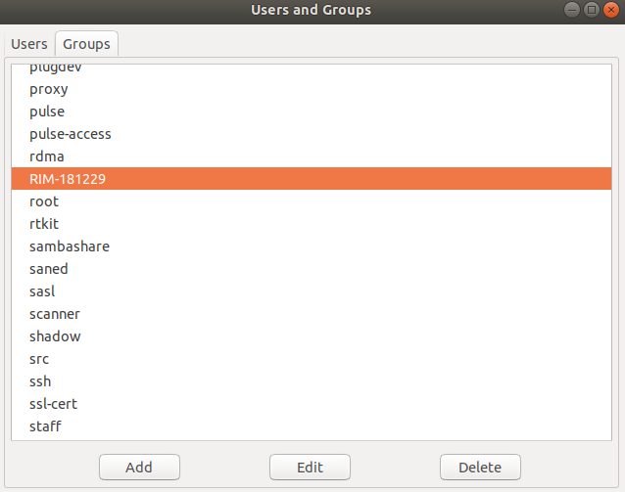

3. PROVE THEIR EXISTENCE BY REVEALING THEIR DATA IN ALL CONFIGURATION FILES

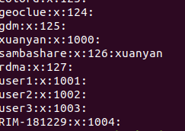

4. WHAT DATA IS STORED ABOUT EVERY USER IN THE FILE WITH USERS’ ACCOUNTS? (EXPLAIN YOUR ANSWER ON THE BASIS OF A PARTICULAR ACCOUNT)

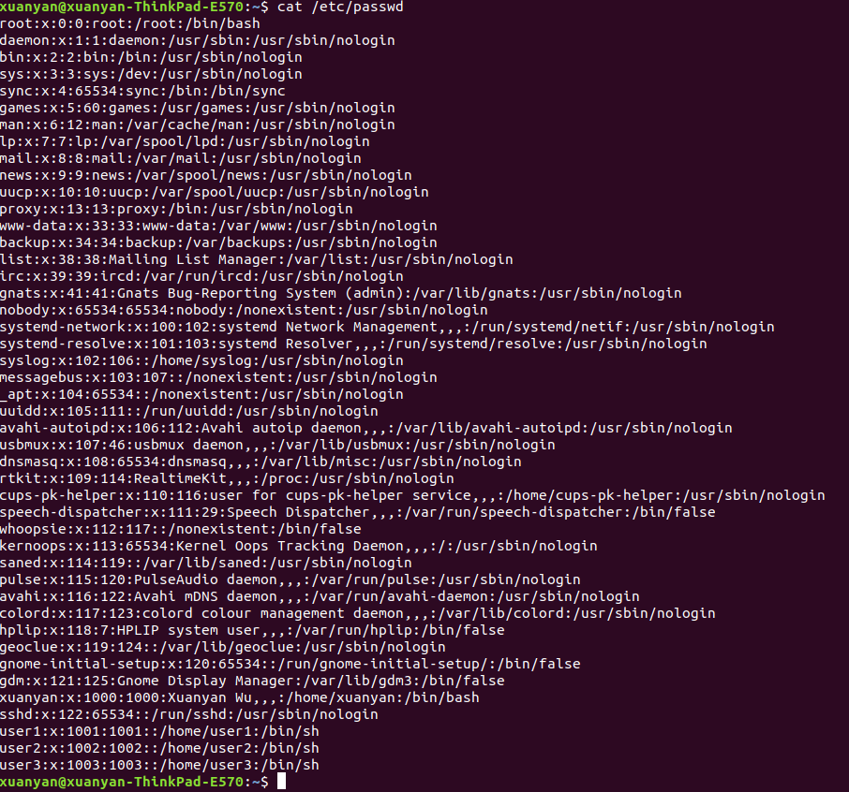

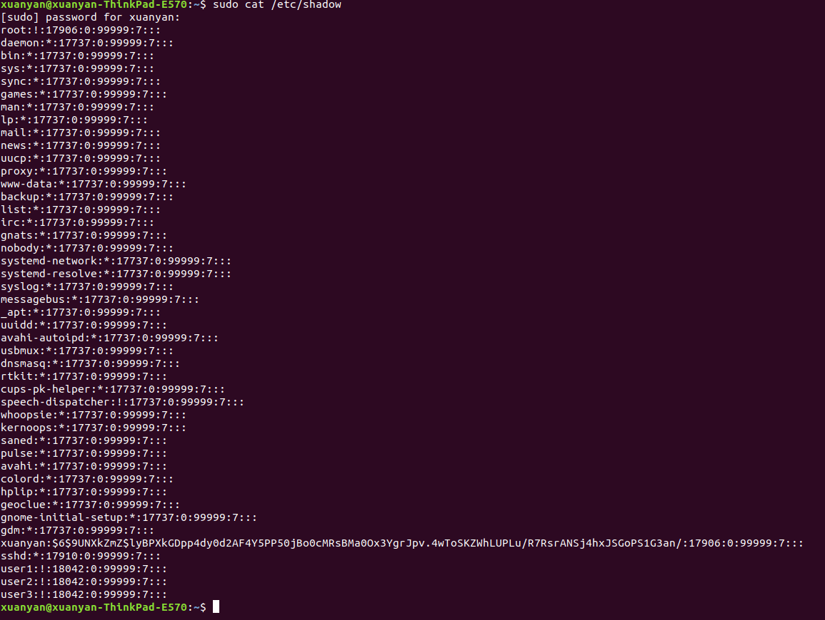

Task2

✓ 1.HOW MANY PROCESSES ARE RUNNING IN YOUR SYSTEM?

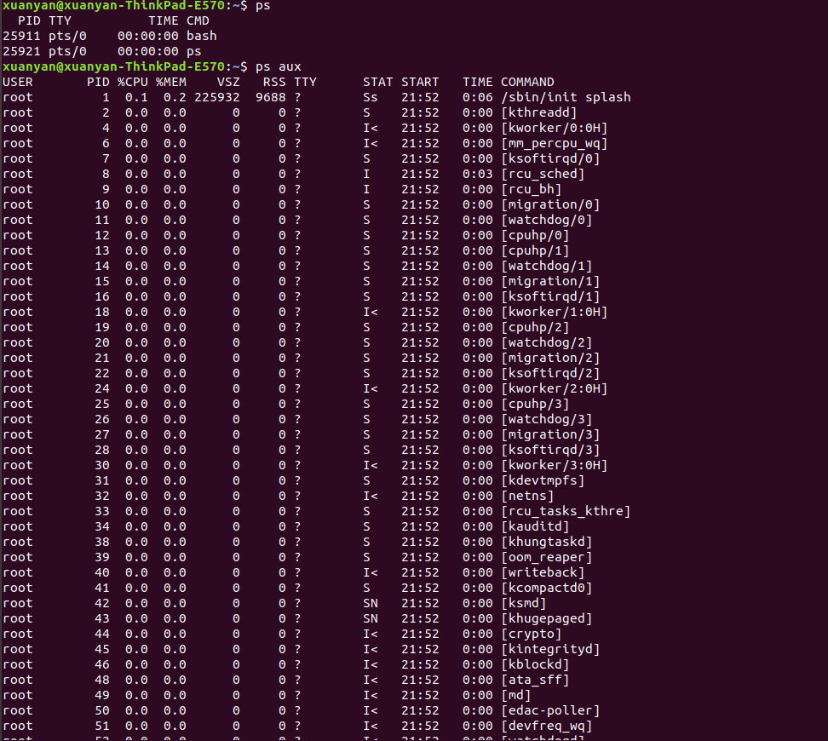

✓2. WHAT INFORMATION ABOUT EVERY PROCESS IS DELIVERED BY “top” TOOL, AND WHAT IS THE

MAIN DIFFERENCE BETWEEN “ps” COMMAND AND “top’’ TOOL?

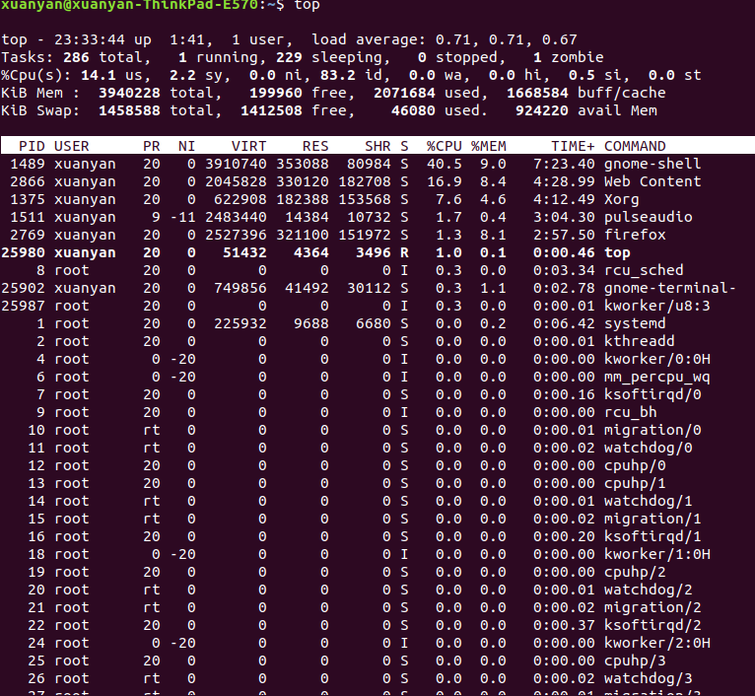we can see that the top command will look at the memory, CPU and process.

top is mostly used interactively (try reading man page or pressing "h" while top is running) and ps is designed for non-interactive use (scripts, extracting some information with shell pipelines etc.)For CPU usage, ps displays average CPU usage over the lifetime of the process as it is instantaneous and would always be 0% or 100%. top gives a more instantaneous look at it from averaging over recent polls.

✓3. CREATE IN YOUR HOME DIRECTORY A HARD LINK AND A SYMLINK TO ONE OF THE DIRECTORIES FROM THE FIRST LEVEL

#ln -s source_file  softlink_file

#ln existfile  newfile

I know how to create a hard link ,but I don’t want to do it for my computer.

✓ 4.WHAT WILL BE DONE WITH THE HELP OF THE COMMAND:

find ./test1 ./test2 -type f -name "*.py"

✓ GIVE THE EXAMPLES OF EVERY COMMAND FROM THE TABLES (SLIDES 25, 27)

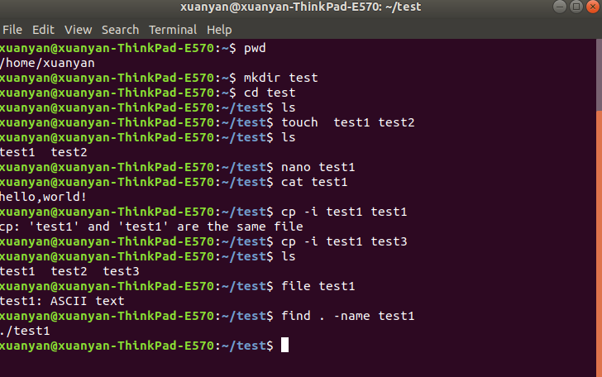

✓ SUPPOSE THAT IN YOUR CURRENT DIRECTORY THERE IS AN EXECUTABLE FILE NAMED “EXAMPLE1”.

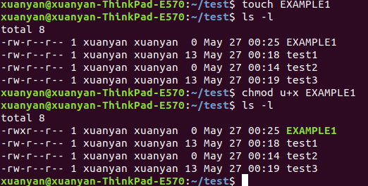

✓ WRITE THE COMMAND TO CHANGE ACCESS PERMISSIONS AND TO GIVE ALL PERMISSIONS TO ITS OWNER,PERMISSION TO READ ANDV EXECUTE TO THE GROUP OWNER, AND ONLY PERMISSION TO EXECUTE TO THE OTHERS.

